MAP ASSIGNMENT-3

I. Event Validation using isNotNull, isEmail, isNumber
Project Name: ValidationRules
Objective:
The goal is to validate the incoming request payload in a specific sequence:
- Check if Not Null → payload.name
- Check for Valid Email → payload.email
- Check for Number within Range (0–100) → payload.marks
Finally, the validated payload should be returned using a Transform Message component.

Step 1: Create a New Project
- Open Anypoint Studio.
- Navigate to File → New → Mule Project.
- Name the project as ValidationRules.
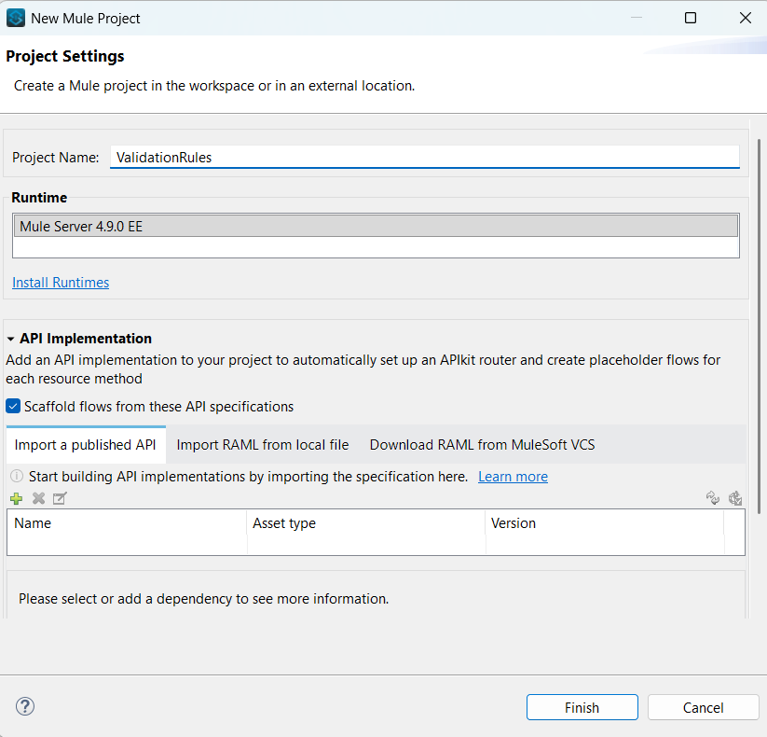
Step 2: Configure HTTP Listener
- Drag an HTTP Listener component into the flow.
- Create a new configuration with the following details:
  - Host: 0.0.0.0
  - Port: 8081
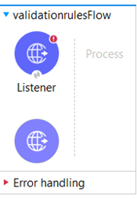
- In the Listener properties:
  - Path: /validation
  - Purpose: This endpoint will accept incoming POST requests.
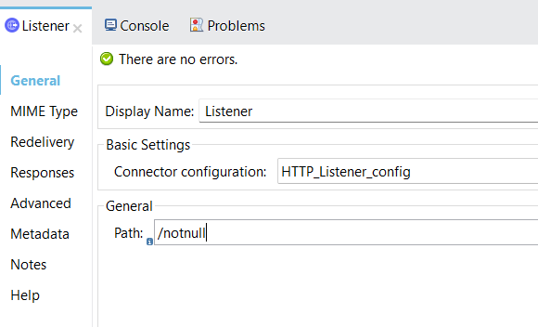

Step 3: Add “Is Not Null” Validation
- Drag a Validation → Is Not Null component after the listener.
- Configure it as follows:
  - Value: #[payload.name]
  - Message: “Name should not be null.”
- Purpose: Ensures the request includes a non-empty name value.

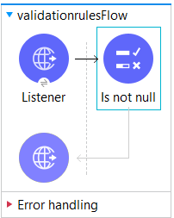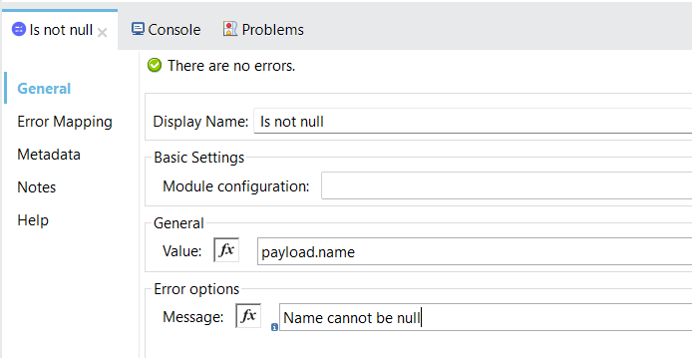

Step 4: Add Transform Message
- Add a Transform Message component at the end of the flow.
- Insert the required DataWeave (DWL) script to return the payload.
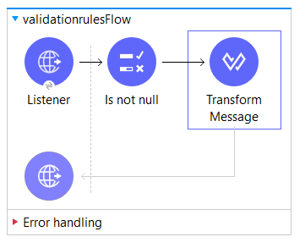
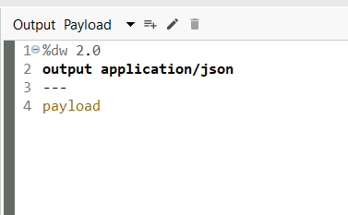

Step 5: Repeat HTTP Configuration (if needed)
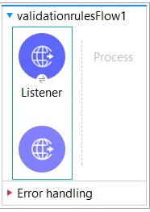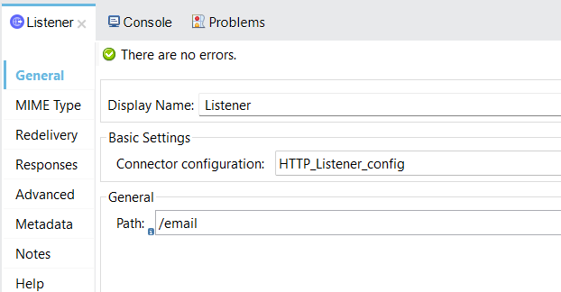

Step 6: Add “Is Email” Validation
- Add a Validation → Is Email component.
- Configure:
  - Value: #[payload.email]
  - Message: “Please enter a valid email address.”
- Purpose: Validates that the email format is correct.
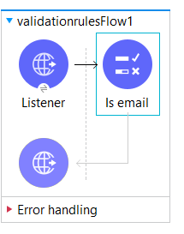

Step 7: Add Transform Message
- Again, add a Transform Message component to display the result.

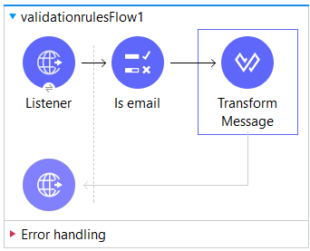
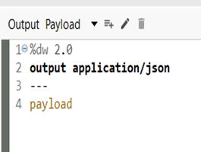

Step 8: Repeat HTTP Configuration (if needed)
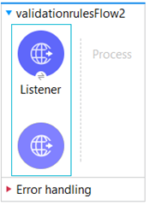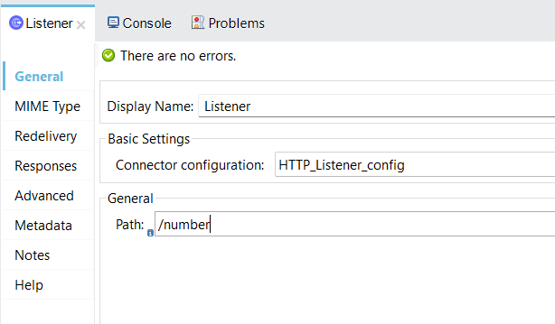

Step 9: Add “Is Number” Validation
- Drag Validation → Is Number into the flow.
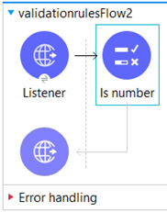
- Configure:
  - Value: #[payload.marks]
  - Message: “Please enter valid marks.”
  - Minimum Value: 0
  - Maximum Value: 100
- Purpose: Confirms that marks are numeric and fall within the range 0–100.
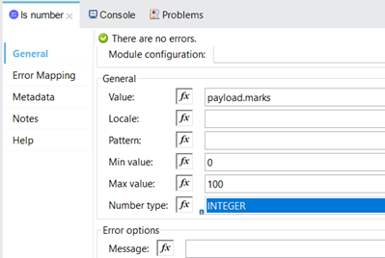

Step 10: Add Transform Message
- Add the final Transform Message to output the validated data.

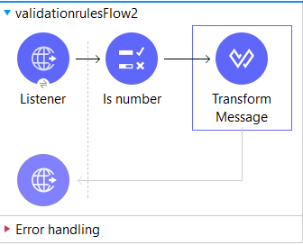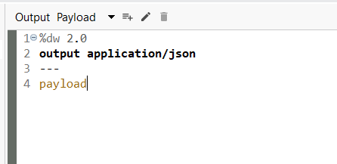

Output:
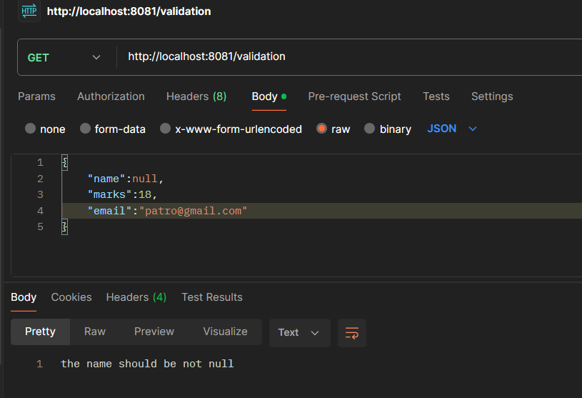
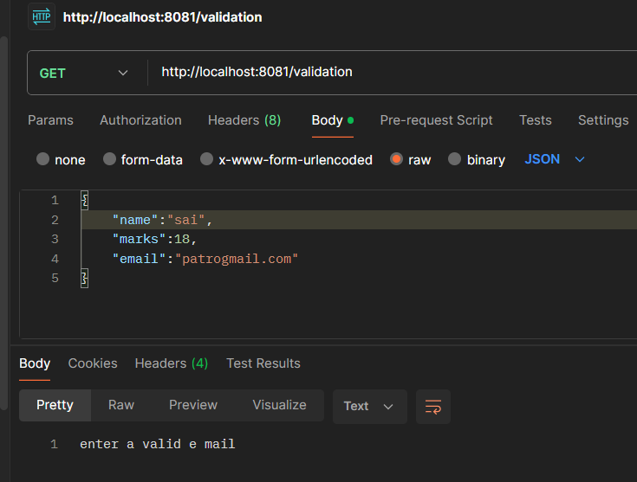
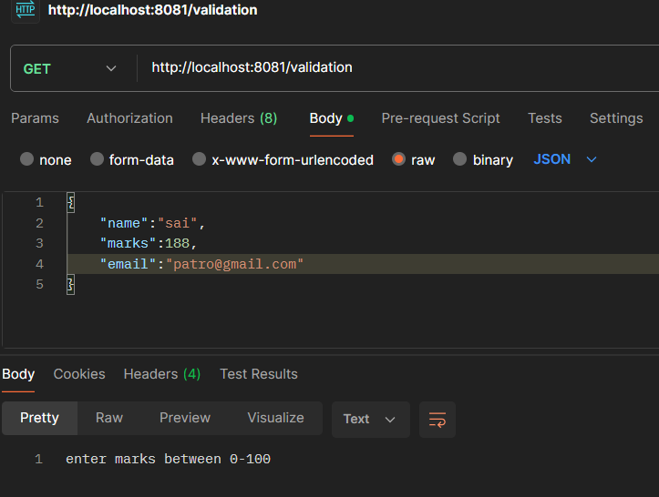

II. Choice Router
Project Name: StudentGrades
Objective:
Accept a student’s marks from the request payload, store them as a variable, and use a Choice Router to determine the corresponding grade:
Marks Range | Grade
≥ 90 | A
≥ 80 | B
≥ 70 | C
≥ 60 | D
≥ 50 | E
≥ 40 | Pass
< 40 | Fail

Step 1: Create a New Project
- Open Anypoint Studio.
- Go to File → New → Mule Project.
- Set the project name as StudentGrades.
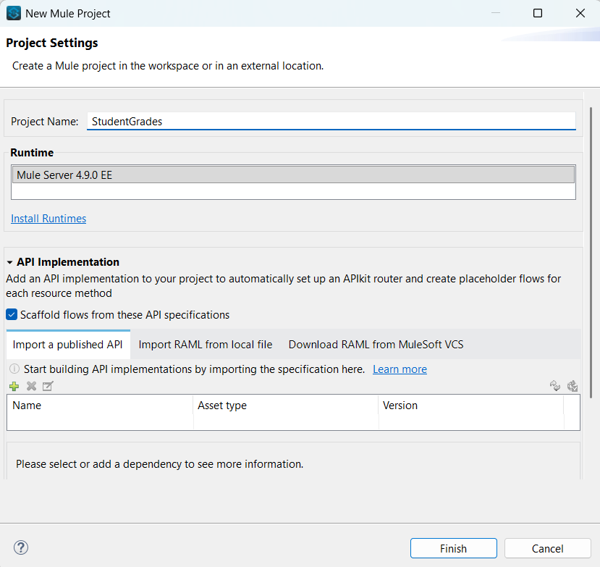
Step 2: Add HTTP Listener
- Drag an HTTP Listener into the flow.
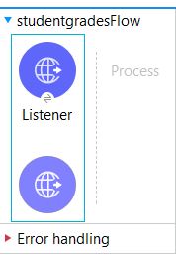
- Configure the listener as follows:
  - Path: /grades
  - Port: 8081
- Purpose: To receive incoming requests containing student marks.
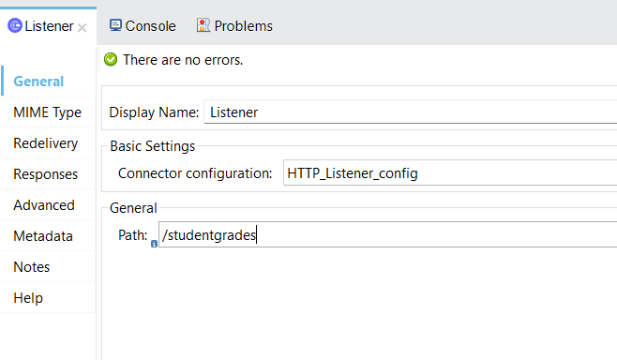

Step 3: Set Variable
- Add a Set Variable component after the listener.
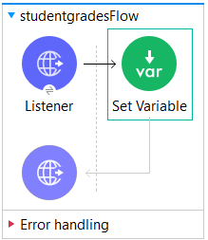
- Configure:
  - Name: grade
  - Value: #[payload.grade]
- Purpose: To store the marks from the incoming request into a variable for further processing.
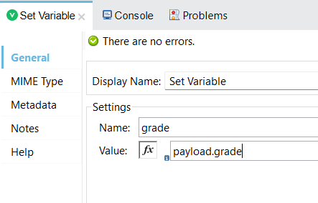
Step 4: Configure Choice Router
- Add a Choice component after the variable.
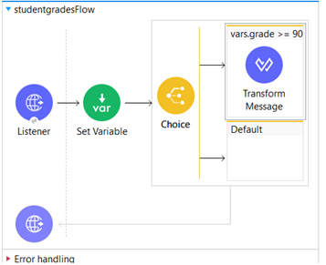
- Define multiple When conditions and a Default case using DW (DataWeave) expressions:
  - #[vars.grade >= 90] → Transform → “Grade: A”
  - #[vars.grade >= 80] → Transform → “Grade: B”
  - #[vars.grade >= 70] → Transform → “Grade: C”
  - #[vars.grade >= 60] → Transform → “Grade: D”
  - #[vars.grade >= 50] → Transform → “Grade: E”
  - #[vars.grade >= 40] → Transform → “Pass”
  - Default: → Transform → “Fail”
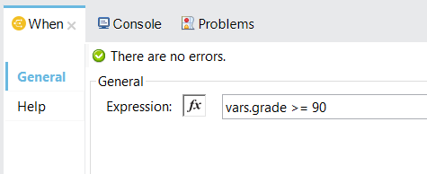
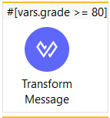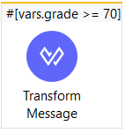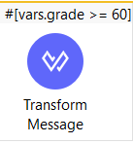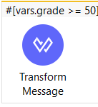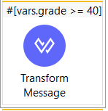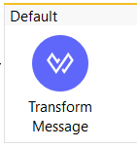

Step 5: Add Transform Message for Each Condition
For each branch, add a Transform Message component that returns the respective grade (for example, “Grade: A”, “Grade: B”, etc.).

Step 6: Run and Test
- Run the Mule Application.
- Test using Postman by sending requests to verify each condition.

